GitHub Account Creation

GitHub is more than a place for programmers to store code. It is a professional portfolio that can help employers see how you organize information, document your work, and communicate your skills.
In this assignment, you will create and configure your GitHub account. The goal is to create a profile that you would feel comfortable linking to on your resume or LinkedIn profile.
By the end of this assignment, you should have a complete and professional-looking GitHub profile.

STEP 1: Create a GitHub account
- Follow the instructions on GitHub’s website to create your account: Creating an account on GitHub
  - Use a professional\formal username - NOT something silly like doggernation or jellyfish15.
  - If you want to continue to have access beyond your time at Iowa, use a personal email.
  - If you only want to use it here at Iowa, feel free to use your uiowa.edu address.
- Next, secure your account with 2 Factor Authentication (2FA): How to setup 2FA in GitHub As a suggestion, just like you might use for your Iowa HawkID account, I use DUO Mobile as my authenticator application on my phone.
- YOU DID IT! You are officially ready to log into GitHub.

STEP 2: Upload your picture and complete your profile

- It’s time to create and personalize your profile. Follow the steps located in this GitHub guide: Personalizing Your Profile
- Complete the following steps:
  - Add your name
  - Create a short bio
  - Upload a picture – This can be a picture of you or something else.
  - Create a home page introduction.
- Once you are done, it should look something like this:
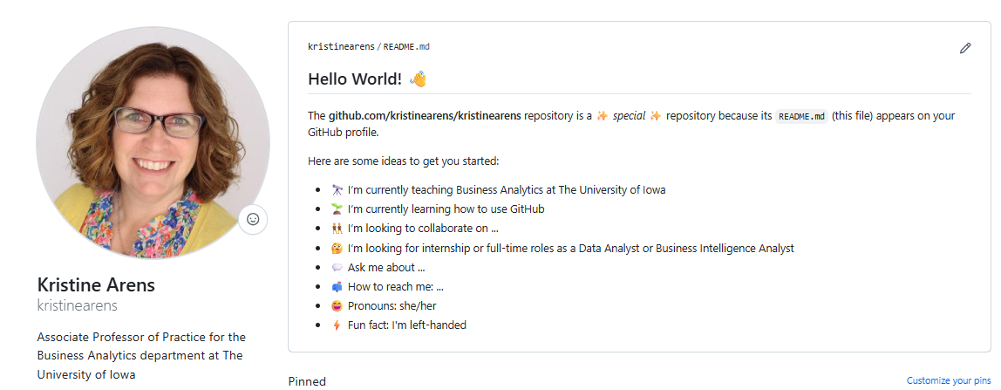
- YOU DID IT! You are done setting up your profile.
- Compare your site with mine to see if you have all the setup steps completed: https://github.com/kristinearens

STEP 3: Submit screenshot
- Follow the instructions on the assignment to submit a screenshot showing your version of the landing page screenshot. This should look similar to mine above, but with your personalized information.

